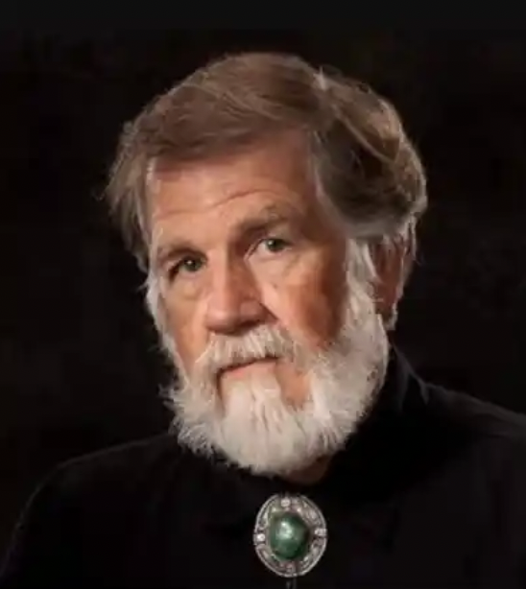

Tom Gilleon was born in 1942 in Gainesville, Florida. Tom’s parents, with three children to raise—including an older sister stricken with polio—sent him to live in the country with his grandparents near Starke, Florida. In a home with no electricity, evening entertainment consisted of sketching and storytelling by the light of a kerosene lamp. Tom learned to draw by watching his immigrant grandfather, a gifted artist and cabinetmaker from Scotland. Tom’s grandmother, also an artist who strongly aligned herself with Native American culture, was more concerned he learn survival skills such as hunting, fishing, gathering edible plants and, above all, dependence on no one. Tom learned to shoot a rifle almost as early as he learned to walk.

Unlike most children, Tom grew up amongst acres of towering pines and a yard made of white sand—a never ending blank canvas upon which to draw. It was there Tom’s art career began to manifest. He created hundreds of drawings with a stick in the sand. Starting with the horizon for spatial definition—he drew the ocean. Then he intersected it with the mast of a ship. By adding a triangle and half-circle to draw a boat and sail, he learned the power of geometric shapes to tell stories. In later years, Tom would incorporate these lessons with his mastery of luminosity, color, and visual storytelling he would learn from some of America’s greatest painters while illustrating at Disney. But it was his passion for the American West that finally inspired his fine art career—giving rise to his world renowned style of Contemporary Art.

